Early research and experiments
Improvement and advancement in sensors and optical tech
Advent and emergence of CubeSat
Growing demand of high-quality imagery data and expansion of its commercial appl
Integration with other satellite payloads to enable new mission
1st & 2nd world war

Late 1950s

1960’s - Present

1970 - 2000

2000 - Present

2000 - Present

2008 - Present

- Advancment of senors
- TV imaging system
- thru early 1985
- Miniaturization of optical payload
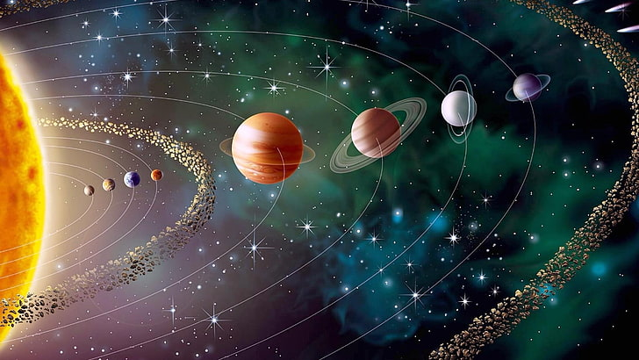
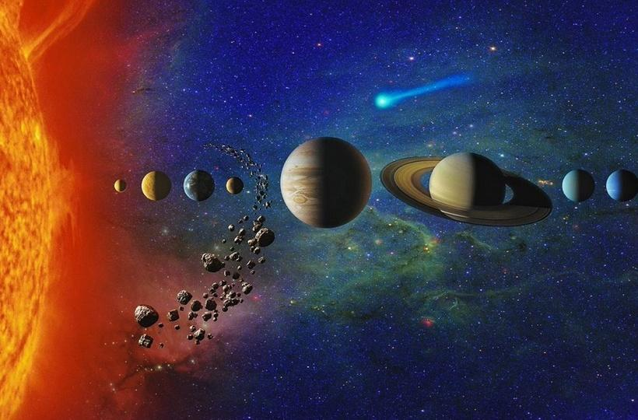
Luna 3
